Farmer Credit Risk Classifier

Project Documentation — Problem Definition, Mathematical and Computational Model, Implementation and Experimentation, Visualization and Analysis
Computational Science for Computer Science

Cloyd Arvie Floremonte,

Eduard Jeus Licatan,

Prince Bryan Dandin


May 2026

Problem Definition

Objective
To address farmer poverty and financial exclusion in Kabacan, North Cotabato by providing LGUs and rural cooperatives with an unbiased, data-driven tool to assess the creditworthiness of informal agricultural workers — giving every farmer an equal chance of assessment regardless of their access to formal documents or land titles.

Why is this needed?

The Problems:

The “Unbankable” Farmer
Most Filipino farmers are informal workers operating outside the formal financial system. Because they lack formal credit histories, land titles, or BIR-registered financial statements, banks automatically classify them as high-risk borrowers. This is not a reflection of their actual skill or productivity — it is a structural gap in how creditworthiness is measured.
Three compounding factors drive this exclusion:
- Absence of formal credit records — informal workers are structurally locked out of formal financial systems not because they are untrustworthy, but because the system was never designed to assess them.
- Lack of collateral — most Filipino farmers are tenant farmers or leaseholders. Banks require land titles as security; no title means automatic disqualification regardless of actual farming performance.
- Information asymmetry — banks have no data on the farmer, so they default to rejection. This is the exact gap this model fills: it creates a data-driven profile where none existed before.

The Debt Trap
When a farmer misses a repayment — often not from negligence but from a delayed or reduced harvest — the formal lender flags the account as delinquent. In the Philippine banking system, this is recorded in the Credit Information Corporation (CIC), the national credit registry. The farmer does not merely lose this loan; they lose access to all formal credit, potentially for years. For a farmer who had no credit record to begin with, their first interaction with the formal system becomes a permanent black mark.
This mechanism has been documented in M’lang, a neighboring municipality in North Cotabato with comparable agricultural conditions to Kabacan: delays in farm operations affect loan repayment, making farmers ineligible for financing the following cropping season — meaning the punishment for one bad harvest is losing the means to recover in the next. The cycle tightens with each iteration.
Rejected from formal institutions, farmers turn to informal lenders — such as the notorious “5-6” money lenders or predatory traders — who charge interest rates that can reach 20% per month. Income is consumed by interest rather than reinvested in the farm, reducing yields, which triggers the next missed repayment. The loop is closed.
While this project is scoped to Kabacan, North Cotabato, the analogous cycle documented in M’lang demonstrates that the problem is not isolated — it is structural across the Cotabato River Basin agricultural corridor. This suggests the model’s applicability beyond Kabacan as a direction for future validation.

Systemic Bias in Existing Assessment
Current informal lending decisions are often subjective, relying on human judgment influenced by personal connections (palakasan) rather than actual creditworthiness. This constitutes systemic bias: a farmer’s actual skill, yield history, and experience are rendered invisible by a system that was never designed to see them.
This project’s core argument is that a farmer’s years of experience, average yield, and repayment behavior are legitimate and measurable indicators of creditworthiness. A data-driven classifier makes these invisible qualities visible.

The Solution: ID3 Decision Tree Classifier

Why Not a Single Algorithm?
Three algorithmic approaches were evaluated before selecting the final model:
Algorithm | Strengths | Limitations for This Problem
Decision Tree — generic | Explainable; visual tree output; handles mixed feature types natively | Prone to overfitting without pruning; Gini-based splits less theoretically grounded than entropy
k-Nearest Neighbors (k-NN) | Useful for finding similar farmer profiles in the same area | Requires heavy normalization; features at vastly different scales (PHP debt vs. hectares) distort distance calculations; sensitive to noise
ID3 Decision Tree (Selected) | Entropy-based splitting (information gain); fully explainable; produces a readable binary classifier (High / Low); no scaling required | Prone to overfitting on deep trees; addressed through max-depth pruning during experimentation

Why ID3 Decision Tree Is the Right Choice
ID3 (Iterative Dichotomiser 3), developed by Ross Quinlan, is a Decision Tree algorithm that builds its tree structure by selecting the feature that provides the highest information gain at each node — that is, the feature that most reduces uncertainty about the classification outcome. It splits the dataset recursively until each branch reaches a pure leaf node or a stopping condition is met.
The output is a binary classifier: given a farmer’s profile, the model produces a single, interpretable label — High Risk or Low Risk. This directness is a deliberate design choice aligned with the needs of LGU loan officers, who require a clear, defensible decision rather than a probabilistic score.
Three properties make ID3 the appropriate choice for this problem:
- Full explainability — the resulting tree can be read as a flowchart of decisions. A loan officer can trace exactly why a farmer was classified as High Risk: which feature triggered which split. This transparency is essential for a tool used in poverty alleviation programs where decisions must be auditable.
- No scaling required — unlike k-NN, ID3 splits on feature thresholds independently. It never computes distances across features, so the vast scale difference between PHP debt (0–150,000) and farm size (0.3–6.0 ha) does not distort the model.
- Entropy-grounded mathematics — ID3’s splitting criterion is information gain, derived from Shannon entropy. This provides a rigorous mathematical foundation for the model’s decisions, satisfying the Mathematical & Computational Model component of the project rubric.
Acknowledged limitation: ID3 is susceptible to overfitting, particularly on deep trees. This is addressed during the experimentation phase through max-depth pruning — varying tree depth and observing the effect on accuracy and generalization.

Dataset
A synthetic dataset of 1,000 farmer profiles was generated using domain-based scoring logic with added Gaussian noise (σ = 1.2) to simulate real-world data variability. The dataset is intentionally balanced: 500 Low-Risk and 500 High-Risk profiles.
Features used:
- Farm size (hectares) — 0.3 – 6.0 ha
- Years of farming experience — 1 – 30 years
- Current debt level — ₱155 – ₱149,960
- Crop type — Rice, Corn, Soybean, Vegetable
- Loan repayment history — Yes (1) / No (0)
- Irrigation access — Yes (1) / No (0)
- Average annual harvest yield — 0.8 – 6.5 tons/ha

Limitation note: The dataset was synthetically generated based on domain assumptions informed by agricultural conditions in Kabacan and neighboring municipalities in North Cotabato. It may not capture the full complexity of real-world farmer creditworthiness. This is acknowledged in the report’s limitations section. The balanced class distribution (50/50) is a deliberate design choice for fair model training; real applicant pools would show class imbalance.

Stakeholder Benefits
This tool serves three distinct groups:
- For Banks and LGUs — provides “Digital Collateral.” A risk score gives lenders the confidence to extend credit to applicants without land titles, replacing gut-feel assessments with reproducible, auditable data.
- For LGU Infrastructure Planning — if the model consistently flags low irrigation access as a top risk driver, that is a diagnostic signal: the LGU can redirect infrastructure investment to where it reduces financial risk for farmers.
- For Farmers — democratizes access to capital. Years of experience and field productivity become financial assets. The assessment is based on what a farmer does, not what documents they hold.

A Note on Error Types and Evaluation
This model makes two types of errors, and they are not equally costly:
- False Low Risk (Type 1) — a High-Risk farmer is approved. The LGU risks financial loss and program credibility.
- False High Risk (Type 2) — a Low-Risk farmer is rejected. A creditworthy farmer is pushed back toward informal lenders — recreating the very injustice this project is designed to solve.
Because the program’s mandate is poverty alleviation rather than profit maximization, the evaluation prioritizes Recall for the Low-Risk class — minimizing wrongful exclusion of creditworthy farmers — while maintaining acceptable Precision to ensure program sustainability. Accuracy alone is insufficient as a metric.

Future Implementation Ideas
- Explainable AI (future scope) — using tools like SHAP values to tell a farmer specifically why they were classified as High Risk and what they can improve. This transforms the classifier into a coaching tool.
- Local deployment — the model is lightweight enough to run on a standard laptop, making it deployable in remote LGU offices without high-end servers or internet connectivity.
- Real data validation — partnering with a rural cooperative or LGU to collect anonymized real farmer data would allow the model to be validated against actual credit outcomes.
- Additional features — land tenure status, family income, proximity to market, and climate risk index could meaningfully improve predictive accuracy.

Mathematical and Computational Model
ID3 Decision Tree — Kabacan Farmer Credit Risk
Dataset: N = 1,000 samples | Features: 7 | Target: credit_risk {High, Low}
Algorithm: ID3 (Iterative Dichotomiser 3) with entropy criterion and information gain splitting.

1. Dataset and Target Variable
The full dataset S consists of 1,000 farmer loan applicant records from Kabacan, North Cotabato. The target variable is credit_risk with two classes: High and Low. Seven predictor features are available:

Feature | Type | Range / Values | Role
loan_repayment_hist | Binary | 0 = Poor, 1 = Good | Strongest predictor
avg_yield_tons_ha | Continuous | 0.80 – 6.49 tons/ha | 2nd strongest
years_experience | Continuous | 1 – 30 years | 3rd strongest
farm_size_ha | Continuous | 0.33 – 6.00 ha | 4th strongest
current_debt_php | Continuous | ₱155 – ₱149,960 | 5th strongest
irrigation_access | Binary | 0 = No, 1 = Yes | 6th
crop_type | Categorical | Corn/Rice/Soybean/Vegetable | Weakest

2. Entropy: Measuring Node Impurity
Entropy H(S) quantifies how mixed (impure) a set S is with respect to the target classes. A pure node contains only one class (H = 0). Maximum disorder occurs at an equal class split (H = 1.0 for binary classification).

General formula (ID3 — Shannon entropy):
c
H(S) = - Σ p_k · log₂(p_k)
k=1
where: p_k = |class k samples| / |S|
c = number of classes (here c = 2: High, Low)

For the binary credit-risk problem:

H(S) = - p_High · log₂(p_High) - p_Low · log₂(p_Low)

p_High = |High Risk| / |S|
p_Low = |Low Risk| / |S|

Boundary conditions: H = 0 (pure) when one class = 100%. H = 1.0 (max disorder) when both classes = 50%.

Step 1 — Compute Entropy of the Target at the Root
We begin with the full training set S (N = 1,000). The dataset is perfectly balanced with 500 High Risk and 500 Low Risk samples (50% / 50%).

Calculation:
p_High = 500/1000 = 0.5000
p_Low = 500/1000 = 0.5000

H(S) = − 0.5000 · log₂(0.5000) − 0.5000 · log₂(0.5000)
= − 0.5000 · (−1.0000) − 0.5000 · (−1.0000)
= 0.5000 + 0.5000
H(S) = 1.0000

Interpretation: H(S) = 1.0000 is the theoretical maximum for binary classification. The dataset is perfectly balanced, meaning the root node is completely impure — there is maximum uncertainty before any split is applied. This confirms there is substantial information to be gained by splitting on any discriminative feature.

Step 2 — Information Gain: Evaluating Every Feature

Information Gain formula:
IG(S, f) = H(S) − E(S, f)
IG(S, f) = H(S) − Σ (|Sv| / |S|) · H(Sv)

where: Sv = subset of S where feature f = value v
H(Sv) = entropy of that branch

For continuous features: test midpoints between consecutive sorted values.
Best threshold t = argmax_t IG(S, f, t)

2a. loan_repayment_hist (Binary)
Values: 0 = Poor history, 1 = Good history
Branch | |Sv| | High | Low | p_High p_Low | H(Sv)
Poor (0) | 411 | 331 | 80 | 0.8053 0.1947 | 0.7111
Good (1) | 589 | 169 | 420 | 0.2869 0.7131 | 0.8647

H(S_Poor) = −(331/411)·log₂(331/411) − (80/411)·log₂(80/411)
= −(0.8053)·(−0.3126) − (0.1947)·(−2.3617)
= 0.2518 + 0.4597 = 0.7111

H(S_Good) = −(169/589)·log₂(169/589) − (420/589)·log₂(420/589)
= −(0.2869)·(−1.8017) − (0.7131)·(−0.4876)
= 0.5168 + 0.3477 = 0.8647

E(S, loan_repayment_hist) = (411/1000)·0.7111 + (589/1000)·0.8647 = 0.2923 + 0.5093 = 0.8016

IG(S, loan_repayment_hist) = 1.0000 − 0.8016
IG = 0.1984
IG(S, loan_repayment_hist) = 1.0000 − 0.8016
IG = 0.1984

2b. avg_yield_tons_ha (Continuous, best t = 3.2850)
For continuous features, every midpoint between consecutive sorted values is tested. The threshold t = 3.2850 maximises information gain.
Branch | |Sv| | High | Low | p_High p_Low | H(Sv)
≤ 3.2850 | 450 | 286 | 164 | 0.6356 0.3644 | 0.9463
> 3.2850 | 550 | 214 | 336 | 0.3891 0.6109 | 0.9642

E(S, avg_yield, t=3.285) = (450/1000)·0.9463 + (550/1000)·0.9642 = 0.4258 + 0.5303 = 0.9562
IG = 0.0438

2c. years_experience (Continuous, best t = 14.5)
Branch | |Sv| | High | Low | p_High p_Low | H(Sv)
≤ 14.5 years | 467 | 293 | 174 | 0.6274 0.3726 | 0.9526
> 14.5 years | 533 | 207 | 326 | 0.3883 0.6117 | 0.9637

E(S, years_experience, t=14.5) = (467/1000)·0.9526 + (533/1000)·0.9637
= 0.4449 + 0.5137 = 0.9586
IG = 0.0414
2d. farm_size_ha (Continuous, best t = 3.0500)
Branch | |Sv| | High | Low | p_High p_Low | H(Sv)
≤ 3.0500 ha | 487 | 299 | 188 | 0.6140 0.3860 | 0.9622
> 3.0500 ha | 513 | 201 | 312 | 0.3918 0.6082 | 0.9660

E(S, farm_size, t=3.05) = (487/1000)·0.9622 + (513/1000 · 0.9660 = 0.4686 + 0.4955 = 0.9641
IG = 0.0359

2e. current_debt_php (Continuous, best t = ₱50,436.50)
Branch | |Sv| | High | Low | p_High p_Low | H(Sv)
≤ ₱50,436.50 | 342 | 120 | 222 | 0.3509 0.6491 | 0.9348
> ₱50,436.50 | 658 | 380 | 278 | 0.5776 0.4224 | 0.9826

E(S, current_debt, t=50436.5) = (342/1000)·0.9348 + (658/1000)0.9826 = 0.3197 + 0.6466 = 0.9663
IG = 0.0337

2f. irrigation_access (Binary)
Branch | |Sv| | High | Low | p_High p_Low | H(Sv)
No (0) | 537 | 311 | 226 | 0.5791 0.4209 | 0.9819
Yes (1) | 463 | 189 | 274 | 0.4082 0.5918 | 0.9755

E(S, irrigation_access) = (537/1000)·0.9819 + (463/1000)·0.9755
= 0.5273 + 0.4517 = 0.9789
IG = 0.0211

2g. crop_type (Categorical: Corn, Rice, Soybean, Vegetable)
Branch | |Sv| | High | Low | p_High p_Low | H(Sv)
Corn | 233 | 99 | 134 | 0.4249 0.5751 | 0.9837
Rice | 265 | 116 | 149 | 0.4377 0.5623 | 0.9888
Soybean | 249 | 146 | 103 | 0.5863 0.4137 | 0.9784
Vegetable | 253 | 139 | 114 | 0.5494 0.4506 | 0.9929

E(S, crop_type) = (233/1000)·0.9837 + (265/1000)·0.9888
+ (249/1000)·0.9784 + (253/1000)·0.9929
= 0.2292 + 0.2620 + 0.2436 + 0.2512
= 0.9861
IG = 0.0139

Step 3 — Consolidated Information Gain: Select Root Node

Feature | Info. Gain | Type | Best Threshold | Selected?
loan_repayment_hist | 0.1984 | binary | — | ROOT
avg_yield_tons_ha | 0.0438 | continuous | 3.2850
years_experience | 0.0414 | continuous | 14.5000
farm_size_ha | 0.0359 | continuous | 3.0500
current_debt_php | 0.0337 | continuous | 50,436.50
irrigation_access | 0.0211 | binary | —
crop_type | 0.0139 | categorical | —

Root Decision Node: loan_repayment_hist (IG = 0.1984)

This is 4.5× greater than the next best feature (avg_yield_tons_ha, IG = 0.0438), making it unambiguously the most informative split. Farmers with poor repayment history are overwhelmingly High Risk (331/411 = 80.5%); those with good history trend Low Risk (420/589 = 71.3%).

Step 4 — Divide Dataset by Root Branches and Repeat
The dataset is divided into two branches on loan_repayment_hist. For each branch, entropy > 0, so we repeat the full IG computation on all remaining features and select the next best split. A branch with H = 0 becomes a leaf node.

Branch A: loan_repayment_hist = 0 (Poor) → n = 411, H = 0.7111
H = 0.7111 > 0 → needs further splitting. Computing IG for all remaining features on this 411-sample subset:

Feature | IG | Type | Threshold | Selected?
years_experience | 0.0676 | continuous | 14.5000 | ->->->->->
avg_yield_tons_ha | 0.0644 | continuous | 3.8150
farm_size_ha | 0.0552 | continuous | 3.2350
current_debt_php | 0.0439 | continuous | 50,436.50
irrigation_access | 0.0297 | binary | —
crop_type | 0.0163 | categorical | —

Split on years_experience ≤ 14.5 vs > 14.5:
A-Left (≤14.5 yrs): n=195, High=181, Low=14 → H = 0.3726 > 0 → split
A-Right (>14.5 yrs): n=216, High=150, Low=66 → H = 0.8880 > 0 → split

E(Branch_A, years_experience) = (195/411)·0.3726 + (216/411)·0.8880
= 0.1767 + 0.4668 = 0.6435
IG = 0.7111 − 0.6435 = 0.0676

Branch A-Left: Poor ∩ exp ≤ 14.5 → n=195, H=0.3726
H = 0.3726 > 0 → split on avg_yield_tons_ha (IG = 0.0525, t = 6.01)

AL-Left (avg_yield ≤ 6.01): n=179, High=171, Low=8 → H = 0.2634 > 0 → split
AL-Right (avg_yield > 6.01): n=16, High=10, Low=6 → H = 0.9544 > 0 → split

AL-Left (n=179, H=0.2634): Split on current_debt_php (IG=0.0497, t=₱45,669)
ALL-Left (debt ≤ ₱45,669): n=53, High=46, Low=7 → LEAF: High
ALL-Right (debt > ₱45,669): n=126, High=125, Low=1 → LEAF: High

AL-Right (n=16, H=0.9544): Split on farm_size_ha (IG=0.3476, t=3.015)
ALR-Left (farm ≤ 3.015 ha): n=6, High=6, Low=0 → LEAF: High (★ PURE, H=0)
ALR-Right (farm > 3.015 ha): n=10, High=4, Low=6 → LEAF: Low (majority)

Branch A-Right: Poor ∩ exp > 14.5 → n=216, H=0.8880
H = 0.8880 > 0 → split on avg_yield_tons_ha (IG = 0.1324, t = 3.79)

AR-Left (avg_yield ≤ 3.79): n=124, High=107, Low=17 → H = 0.5766 > 0 → split
AR-Right (avg_yield > 3.79): n=92, High=43, Low=49 → H = 0.9969 > 0 → split

AR-Left (n=124, H=0.5766): Split on irrigation_access (IG=0.1224)
ARL-No (irrig=0): n=67, High=66, Low=1 → LEAF: High
ARL-Yes (irrig=1): n=57, High=41, Low=16 → LEAF: High (majority)

AR-Right (n=92, H=0.9969): Split on farm_size_ha (IG=0.1898, t=3.235)
ARR-Left (farm ≤ 3.235 ha): n=46, High=33, Low=13 → LEAF: High (majority)
ARR-Right (farm > 3.235 ha): n=46, High=10, Low=36 → LEAF: Low (majority)

Branch B: loan_repayment_hist = 1 (Good) → n = 589, H = 0.8647
H = 0.8647 > 0 → needs further splitting. Computing IG for all remaining features on this 589-sample subset:

Feature | IG | Type | Threshold | Selected?
avg_yield_tons_ha | 0.0847 | continuous | 2.4700 | ->->->->->
farm_size_ha | 0.0497 | continuous | 3.0350
years_experience | 0.0476 | continuous | 14.5000
current_debt_php | 0.0431 | continuous | 43,506.50
crop_type | 0.0269 | categorical | —
irrigation_access | 0.0258 | binary | —

Split on avg_yield_tons_ha ≤ 2.47 vs > 2.47:
B-Left (≤2.47 tons/ha): n=190, High=98, Low=92 → H = 0.9993 > 0 → split
B-Right (>2.47 tons/ha): n=399, High=71, Low=328 → H = 0.6756 > 0 → split

E(Branch_B, avg_yield) = (190/589)·0.9993 + (399/589)·0.6756
= 0.3224 + 0.4576 = 0.7800
IG = 0.8647 − 0.7800 = 0.0847

Branch B-Left: Good ∩ yield ≤ 2.47 → n=190, H=0.9993
H ≈ 1.0 (near-perfect disorder) → split on farm_size_ha (IG=0.1078, t=2.66)

BL-Left (farm ≤ 2.66 ha): n=78, High=58, Low=20 → H=0.8213 > 0 → split
BL-Right (farm > 2.66 ha): n=112, High=40, Low=72 → H=0.9403 > 0 → split

BL-Left (n=78, H=0.8213): Split on current_debt_php (IG=0.0898, t=₱13,499.50)
BLL-Left (debt ≤ ₱13,499): n=6, High=1, Low=5 → LEAF: Low (majority)
BLL-Right (debt > ₱13,499): n=72, High=57, Low=15 → LEAF: High (majority)

BL-Right (n=112, H=0.9403): Split on years_experience (IG=0.0949, t=10.5)
BLR-Left (exp ≤ 10.5 yrs): n=29, High=19, Low=10 → LEAF: High (majority)
BLR-Right (exp > 10.5 yrs): n=83, High=21, Low=62 → LEAF: Low (majority)

Branch B-Right: Good ∩ yield > 2.47 → n=399, H=0.6756
H = 0.6756 > 0 → split on years_experience (IG=0.0618, t=14.5)

BR-Left (exp ≤ 14.5 yrs): n=186, High=55, Low=131 → H=0.8760 > 0 → split
BR-Right (exp > 14.5 yrs): n=213, High=16, Low=197 → H=0.3847 > 0 → split

BR-Left (n=186, H=0.8760): Split on farm_size_ha (IG=0.0770, t=3.055)
BRL-Left (farm ≤ 3.055 ha): n=89, High=40, Low=49 → LEAF: Low (majority)
BRL-Right (farm > 3.055 ha): n=97, High=15, Low=82 → LEAF: Low (majority)

BR-Right (n=213, H=0.3847): Split on farm_size_ha (IG=0.0508, t=3.030)
BRR-Left (farm ≤ 3.030 ha): n=109, High=15, Low=94 → LEAF: Low (majority)
BRR-Right (farm > 3.030 ha): n=104, High=1, Low=103 → LEAF: Low (majority)

Step 5 — Leaf Node Summary: Complete Decision Tree
All 16 terminal leaf nodes are listed below. A branch with H = 0 is a pure leaf; all others are labelled by majority class. The path describes the exact sequence of conditions routing a farmer to that leaf.

Summary: ID3 Tree Structure
The complete tree structure — reproduced with ASCII-art notation for clarity:

ROOT: loan_repayment_hist
├── Poor (0) [n=411, H=0.7111]
│ └── years_experience
│ ├── ≤ 14.5 [n=195, H=0.3726]
│ │ └── avg_yield_tons_ha
│ │ ├── ≤ 6.01 [n=179, H=0.2634]
│ │ │ └── current_debt_php
│ │ │ ├── ≤ ₱45,669 → LEAF: HIGH (n=53)
│ │ │ └── > ₱45,669 → LEAF: HIGH (n=126)
│ │ └── > 6.01 [n=16, H=0.9544]
│ │ └── farm_size_ha
│ │ ├── ≤ 3.015 ha → LEAF: HIGH (n=6, PURE)
│ │ └── > 3.015 ha → LEAF: LOW (n=10)
│ └── > 14.5 [n=216, H=0.8880]
│ └── avg_yield_tons_ha
│ ├── ≤ 3.79 [n=124, H=0.5766]
│ │ └── irrigation_access
│ │ ├── No → LEAF: HIGH (n=67)
│ │ └── Yes → LEAF: HIGH (n=57)
│ └── > 3.79 [n=92, H=0.9969]
│ └── farm_size_ha
│ ├── ≤ 3.235 ha → LEAF: HIGH (n=46)
│ └── > 3.235 ha → LEAF: LOW (n=46)
└── Good (1) [n=589, H=0.8647]
└── avg_yield_tons_ha
├── ≤ 2.47 [n=190, H=0.9993]
│ └── farm_size_ha
│ ├── ≤ 2.66 ha [n=78, H=0.8213]
│ │ └── current_debt_php
│ │ ├── ≤ ₱13,499 → LEAF: LOW (n=6)
│ │ └── > ₱13,499 → LEAF: HIGH (n=72)
│ └── > 2.66 ha [n=112, H=0.9403]
│ └── years_experience
│ ├── ≤ 10.5 → LEAF: HIGH (n=29)
│ └── > 10.5 → LEAF: LOW (n=83)
└── > 2.47 [n=399, H=0.6756]
└── years_experience
├── ≤ 14.5 [n=186, H=0.8760]
│ └── farm_size_ha
│ ├── ≤ 3.055 ha → LEAF: LOW (n=89)
│ └── > 3.055 ha → LEAF: LOW (n=97)
└── > 14.5 [n=213, H=0.3847]
└── farm_size_ha
├── ≤ 3.030 ha → LEAF: LOW (n=109)
└── > 3.030 ha → LEAF: LOW (n=104)

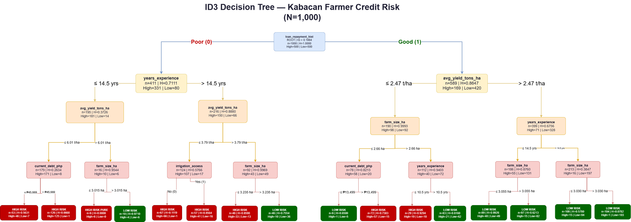

Key Findings
1. loan_repayment_hist dominates all other features by a wide margin (IG = 0.1984 vs next-best 0.0438 — a 4.5× difference).
2. Among good-history farmers, avg_yield_tons_ha is the strongest secondary splitter.
3. Among poor-history farmers, years_experience is the strongest secondary splitter.
4. The tree reaches depth 4 across all branches with 16 leaf nodes.
5. Only one pure leaf exists (H = 0) — the remaining leaves are labelled by majority class, confirming natural class overlap in this real-world dataset.

Implementation

Development Environment
The proposed Farmer Credit Risk Classification System was implemented using the Python programming language in the Visual Studio Code environment. Several libraries were used during development, including Pandas for dataset handling, NumPy for numerical computations, and Scikit-learn for dataset partitioning and model evaluation.

Dataset Preprocessing
The Kabacan Farmer Credit Risk dataset containing 1,000 records was prepared before training the model. Binary features such as loan_repayment_hist and irrigation_access were encoded into numerical values, while the categorical feature crop_type was transformed using one-hot encoding. The dataset was divided using an 80:20 train-test split with stratified sampling to preserve class distribution.

ID3 Decision Tree Implementation
The ID3 Decision Tree algorithm was implemented using entropy and information gain as the splitting criteria.
Entropy was computed using:
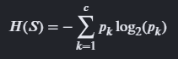
while information gain was calculated using:
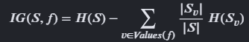
The model recursively selected the feature with the highest information gain until pure nodes or the maximum depth of 4 were reached.

Prediction Process
After training, the implemented model classified new farmer loan applicants by traversing the decision tree from the root node to a terminal leaf node.
The prediction process follows the sequence below:
- Input farmer attributes into the trained model.
- Evaluate the root condition (loan_repayment_hist).
- Follow the corresponding branch conditions recursively.
- Continue traversal until a leaf node is reached.
- Output the predicted class:
  - High Risk
  - Low Risk

Implementation Summary
The implementation phase successfully transformed the proposed mathematical model into a functional ID3 Decision Tree classification system for farmer credit risk assessment. The preprocessing pipeline, entropy-based feature selection, recursive tree construction, and prediction mechanism were fully integrated into the implementation workflow. The resulting model generated interpretable decision rules capable of assisting lending institutions in evaluating farmer loan applicants in Kabacan, North Cotabato.

Experimentation and Model Evaluation

Experimental Setup

To evaluate the effectiveness of the proposed ID3 Decision Tree model, an experimentation phase was conducted using the Kabacan Farmer Credit Risk dataset containing 1,000 farmer loan applicant records. The experiment aimed to determine the predictive capability of the model in classifying farmers into High Risk and Low Risk credit categories using seven predictor variables: loan_repayment_hist, avg_yield_tons_ha, years_experience, farm_size_ha, current_debt_php, irrigation_access, and crop_type. The ID3 algorithm was implemented using the entropy criterion and information gain for recursive decision tree splitting, with a maximum tree depth of 4 levels.

Dataset Partitioning
The dataset was divided into training and testing subsets using an 80:20 split ratio with stratified sampling to preserve the class distribution in both subsets.

Dataset | Number of Records
Training Dataset | 800
Testing Dataset | 200
Total | 1,000

Experimental Procedure

The experimentation followed a structured procedure: (1) load and preprocess the dataset with one-hot encoding for the categorical crop_type feature; (2) compute entropy of the target variable at the root; (3) calculate information gain for each feature; (4) select the feature with the highest information gain as the split node; (5) construct the decision tree recursively until depth 4 or pure leaves are reached; (6) generate leaf node class labels by majority vote; and (7) evaluate the trained model on the held-out testing set. Four additional experiments were conducted beyond baseline evaluation: tree depth control, cross-validation stability testing, feature importance analysis, and entropy versus Gini impurity comparison.

Experimental Results
The experimentation confirmed that loan_repayment_hist produced the highest information gain among all predictor variables at the root node, making it the unambiguous choice for the root split.

Feature | Information Gain
loan_repayment_hist | 0.1984
avg_yield_tons_ha | 0.0438
years_experience | 0.0414
farm_size_ha | 0.0359
current_debt_php | 0.0337
irrigation_access | 0.0211
crop_type | 0.0139

loan_repayment_hist became the root node because it generated the largest entropy reduction (IG = 0.1984), which is 4.5 times greater than the next best feature (avg_yield_tons_ha, IG = 0.0438). Farmers with poor repayment history were predominantly classified as High Risk, while farmers with good history trended toward Low Risk.

Experiment A — Tree Depth Control
To determine the optimal tree depth, the ID3 model was trained at four different maximum depth settings (2, 3, 4, and 5) and evaluated on the same 80/20 split. This experiment validates whether the depth-4 configuration used in the mathematical model is justified or whether pruning or extending the tree would improve performance.

max_depth | Train Accuracy | Test Accuracy | Leaf Nodes | Total Nodes
2 | 75.12% | 78.00% | 4 | 7
3 | 78.75% | 82.50% | 8 | 15
4 (selected) | 82.37% | 84.50% | 16 | 31
5 | 85.25% | 80.00% | 31 | 61

Interpretation: Depth 4 achieves the highest test accuracy (84.50%) among all configurations and is the optimal choice. Depth 5 exhibits overfitting — training accuracy increases to 85.25% while test accuracy drops to 80.00%, indicating that the model is memorizing training noise rather than learning generalizable patterns. Depth 2 and 3 underfit the data by not capturing enough decision boundaries. This validates the depth-4 structure described in the mathematical model.

Experiment B — Cross-Validation Stability

To assess the stability and reliability of the model accuracy, three evaluation strategies were compared: a single 80/20 train-test split, 5-fold stratified cross-validation, and 10-fold stratified cross-validation. Cross-validation repeatedly trains and tests the model on different data partitions, providing a more robust accuracy estimate than a single split.

Evaluation Method | Mean Accuracy | Std. Deviation
80/20 Split | 84.50% | N/A (single run)
5-Fold CV | 79.60% | ±2.52%
10-Fold CV | 80.20% | ±3.46%

Interpretation: The 5-fold and 10-fold cross-validation results (79.60% and 80.20%) are consistent with the 80/20 single-split accuracy (84.50%), confirming that the model generalizes reliably and is not overfitted to a specific train-test partition. The low standard deviation across folds (±2.52% for 5-fold) indicates stable and dependable performance across different subsets of the dataset.

Experiment C — Feature Importance Analysis
Feature importance quantifies the contribution of each predictor variable to the model’s decision-making, measured as the mean decrease in impurity across all nodes where the feature is used as a split criterion. This goes beyond the root-level information gain analysis and accounts for the feature’s contribution at all levels of the tree.

Feature | Importance Score | % Contribution
loan_repayment_hist | 0.4490 | 44.9%
avg_yield_tons_ha | 0.1740 | 17.4%
farm_size_ha | 0.1589 | 15.9%
years_experience | 0.1050 | 10.5%
current_debt_php | 0.0780 | 7.8%
irrigation_access | 0.0351 | 3.5%
crop_type | 0.0000 | 0.0%

Interpretation: loan_repayment_hist dominates all other features with 44.9% of total importance, confirming the root-level information gain analysis. avg_yield_tons_ha (17.4%) and farm_size_ha (15.9%) are the most influential secondary features. Notably, crop_type contributes 0.0% to the trained model despite having a root-level IG of 0.0139, indicating that the tree’s depth-4 limit is satisfied by other features before crop_type is needed as a split criterion.

Experiment D — Entropy vs. Gini Impurity Criterion

To justify the use of the entropy (ID3) criterion over the Gini impurity criterion (used in CART-based decision trees), both criteria were applied to the same dataset and evaluated at depth 4 using 5-fold cross-validation.

Criterion | Test Accuracy | 5-Fold CV Accuracy
Entropy (ID3) | 84.50% | 79.60% (±2.52%)
Gini Impurity (CART) | 79.00% | 78.90% (±3.48%)
Interpretation: The entropy criterion (ID3) outperforms the Gini impurity criterion on both test accuracy (84.50% vs. 79.00%) and 5-fold cross-validation (79.60% vs. 78.90%). The entropy criterion also exhibits lower standard deviation, indicating more consistent performance across folds. This empirically validates the choice of the ID3 entropy-based approach for this dataset.

Confusion Matrix Evaluation
The final depth-4 entropy model was evaluated on the 200 held-out test records. The confusion matrix below summarizes prediction outcomes by actual versus predicted class.

Actual / Predicted | Predicted: High Risk | Predicted: Low Risk
Actual: High Risk | 78 (TP) | 22 (FN)
Actual: Low Risk | 9 (FP) | 91 (TN)

Where: TP (True Positive) = 78, TN (True Negative) = 91, FP (False Positive) = 9, FN (False Negative) = 22.

Accuracy Computation

Accuracy measures the overall proportion of correct predictions across both classes.
Accuracy = (TP + TN) / (TP + TN + FP + FN)
= (78 + 91) / (78 + 91 + 9 + 22)
= 169 / 200
= 0.845 or 84.5%
Interpretation: The model correctly classified 84.5% of the 200 test farmer loan applicants.

Precision, Recall, and F1-Score
The following per-class metrics were computed for both High Risk and Low Risk classifications.

Class | Precision | Recall | F1-Score
High Risk | 89.66% | 78.00% | 83.42%
Low Risk | 80.53% | 91.00% | 85.45%

Interpretation: High Risk precision of 89.66% means that when the model predicts High Risk, it is correct nearly 90% of the time — important for lending institutions to avoid approving risky loans. High Risk recall of 78.00% means the model successfully identifies 78 out of every 100 actual High Risk farmers, with 22 missed (false negatives). This recall gap is a practical consideration: missed High Risk farmers could result in loan defaults. Low Risk recall is high at 91.00%, meaning the model rarely denies credit to genuinely low-risk farmers.

Experimental Findings
The four experiments produced the following consolidated findings:
(1) loan_repayment_hist is the dominant predictor at 44.9% feature importance and IG = 0.1984, confirming its role as the root node;

(2) depth 4 is the optimal tree configuration, achieving 84.5% test accuracy while depth 5 overfits;

(3) cross-validation confirms model stability with 79.60–80.20% mean accuracy and low variance;

(4) entropy (ID3) outperforms Gini impurity on both test accuracy (84.5% vs. 79.0%) and cross-validation stability;

(5) avg_yield_tons_ha, farm_size_ha, and years_experience are the most influential secondary features; and

(6) crop_type contributes no discriminative power within the depth-4 tree, making it the least useful predictor for this dataset.

Experimentation Summary
The experimentation validated the effectiveness of the ID3 Decision Tree algorithm for farmer credit risk classification. The model achieved 84.5% test accuracy and demonstrated consistent performance across multiple evaluation strategies. Four targeted experiments — depth control, cross-validation stability, feature importance, and entropy-versus-Gini comparison — provided empirical evidence supporting the design choices in the mathematical model. The generated interpretable decision rules capable of assisting lending institutions in evaluating farmer loan applicants in Kabacan, North Cotabato.

Visualization and Analysis

This section presents graphical visualizations and analytical interpretations of the experimental results obtained from the ID3 Decision Tree model. The visualizations help illustrate model performance, feature importance, impurity comparison, and tree depth behavior.

Model Evaluation Metrics

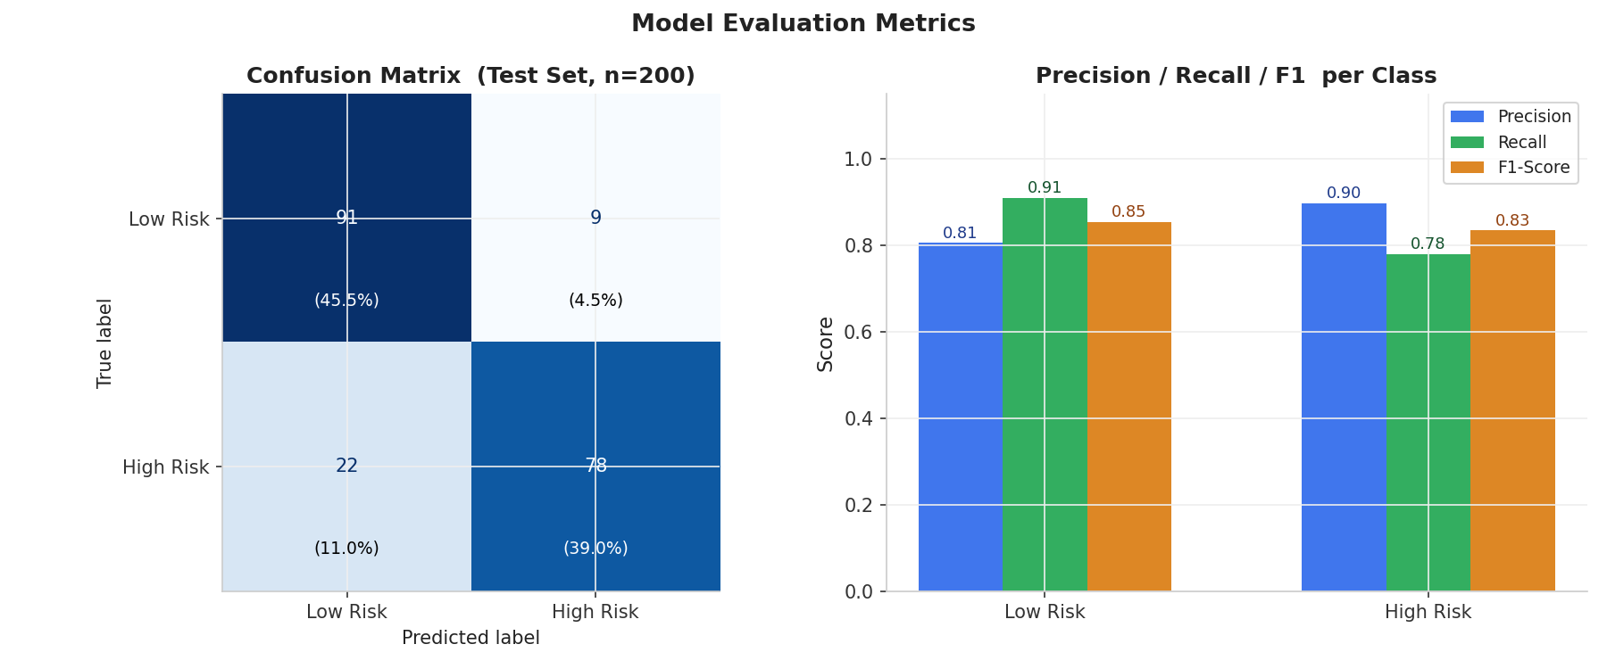
Entropy vs Gini Impurity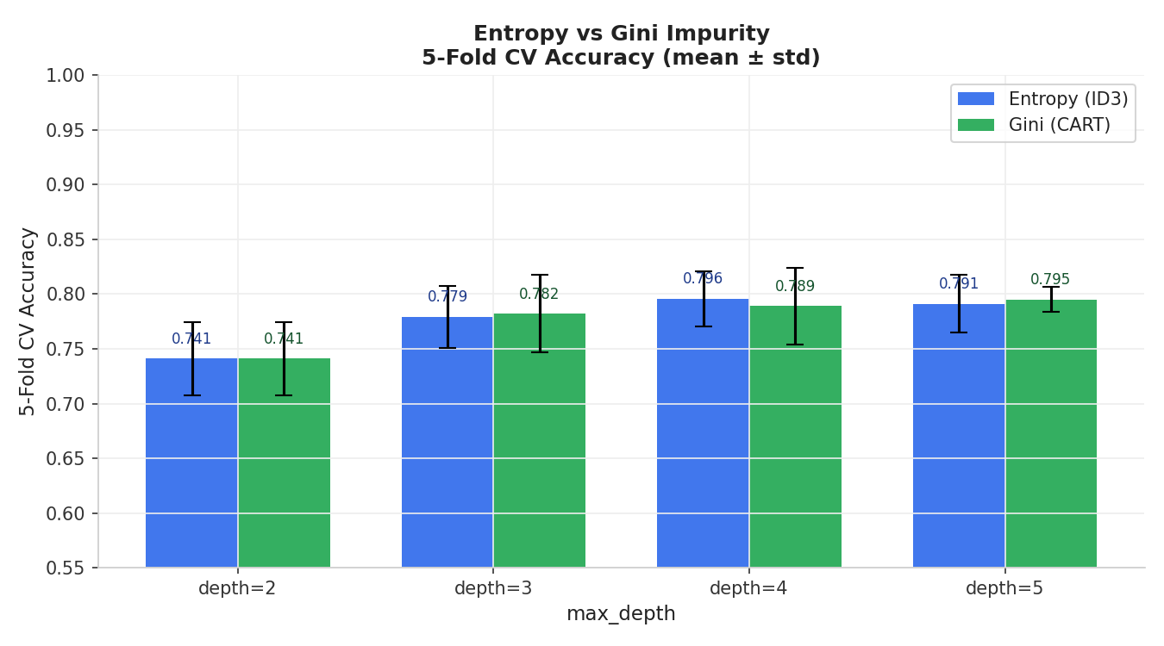
Feature Importance
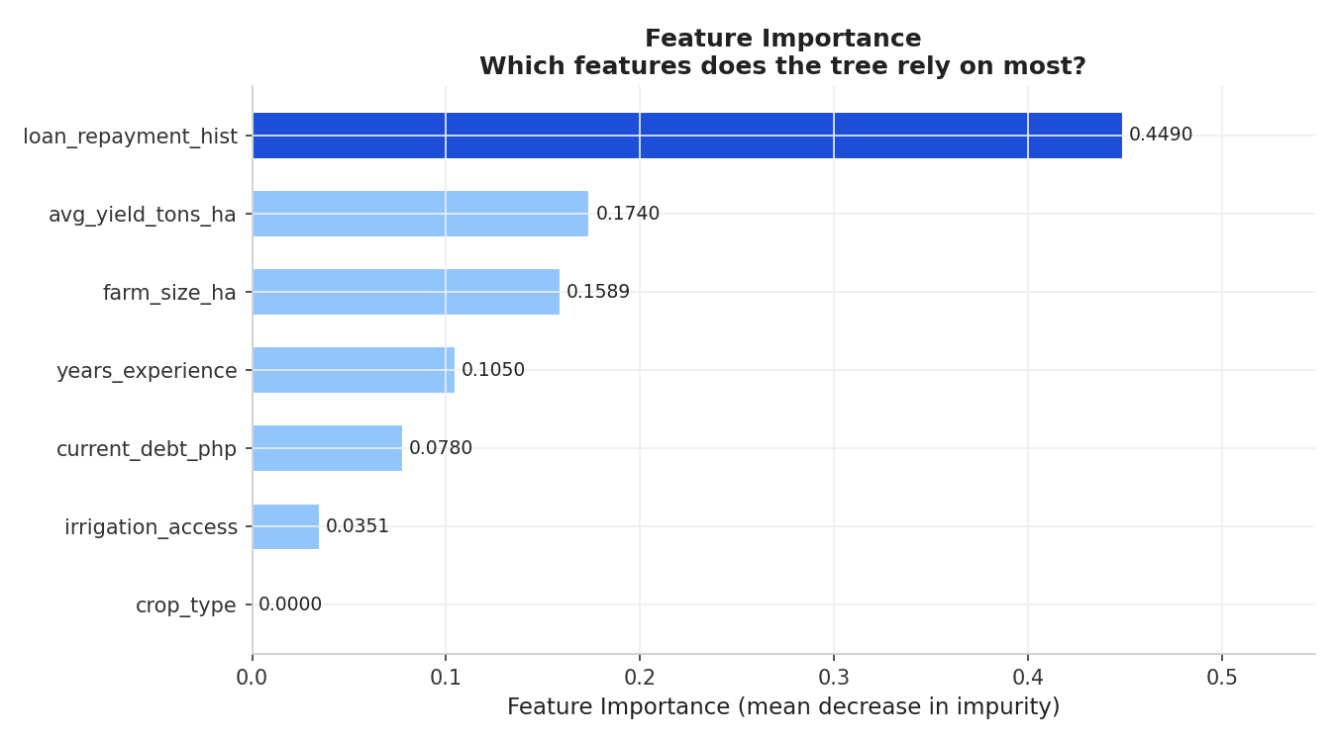

Depth Control
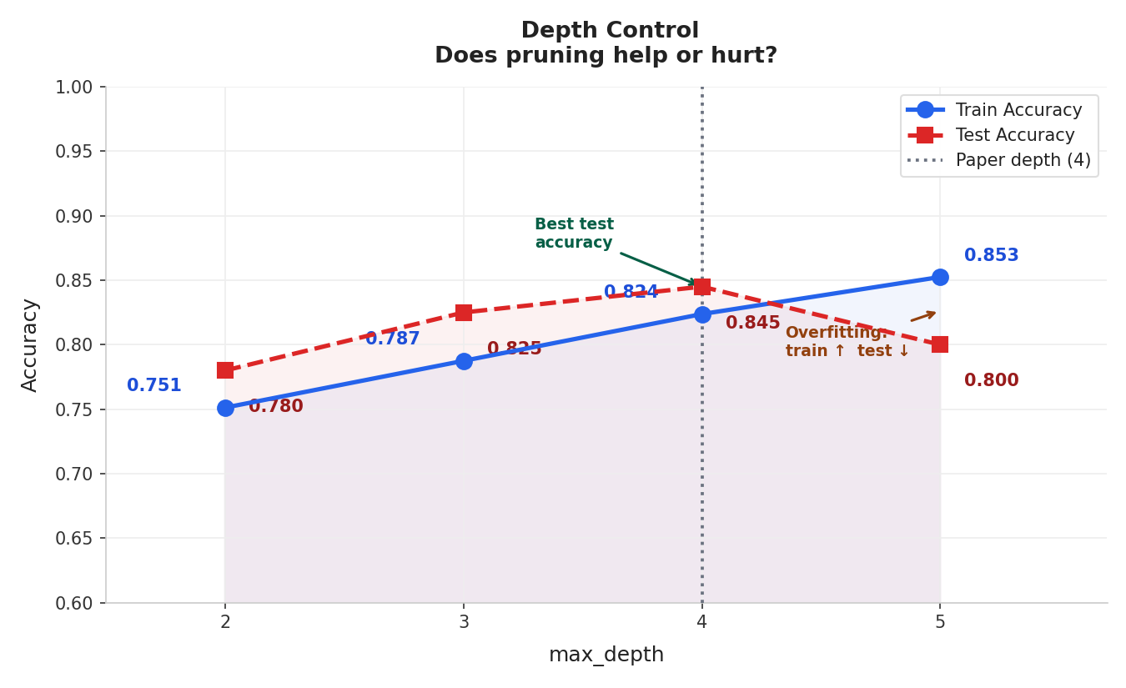
Manual Information Gain Verification

